Contents

**List of figures** 2

**List of tables** 3

**List of abbreviations** 3

**Abstract** 4

1 **Introduction** 5

**1.1 Problem Statement** 5

**1.2 Problem solving** 6

**1.3 Objectives** 7

**1.4 Scope & Constraints** 8

**2 Literature Review** 9

**2.1 Introduction** 9

**2.2 Reviewing the literature** 10

**2.2.1 Entity-Relationship Modeling for Employment Databases** 10

**2.2.2 Relational Database Normalization** 10

**2.2.3 Role-Based Access Control (RBAC) for Security** 10

**2.2.4 Automation Using Triggers and Stored Procedures** 11

**2.3 Findings & Discussion** 12

**3 Methodology** 13

**3.1 Requirement Analysis** 13

**3.2 System Design** 13

**3.2.1 Architectural design** 13

**3.2.2 UML Diagrams System** 14

**3.3 System Implementation/ Prototyping** 14

**3.3.1 Table creation & Insertion** 14

**3.4 Testing** 21

**4 System Initiation and Planning** 22

**4.1 Assessing Project feasibility** 22

**4.1.1 Technical feasibility** 22

**4.1.2 Economic feasibility** 22

**4.1.3 Operational feasibility** 22

**4.1.4 Legal feasibility** 23

**4.2 Project Plan** 23

**5: System Analysis** 25

5.1 **Determining System Requirements** 25

**5.1.1 Functional requirements** 25

**5.1.2 Non-Functional Conditions** 26

**5.2 Structuring System Requirements** 26

**6: Conclusion** 27

**6.1 Advantages of the System** 27

**6.2 Future Enhancement of the System** 27

**6.3 Potential Benefit** 28

**6.4 Conclusion** 29

**References List** 30

16 Appendices 33

TT Holding Database Design

# **List of figures**

Figure 1 UML diagram

Figure 2 Job Position Table creation

Figure 3 Job Position table insertion

Figure 4 Employment Type Table

Figure 5 Employment Table

Figure 6 Person Position Table

Figure 7 Organization Table

Figure 8 Person Table

Figure 9 Employment view table

Figure 10 Position view Table

Figure 11 Update employee table

Figure 12 Delete employee table

Figure 13 Delete Person Position table

Figure 14 Update Person Position table

Figure 15 Triggers creation

Figure 16 Procedure Creation

Figure 17 Function creation

Figure 18 users’ creation

Figure 19 ER Diagram

Figure 20 Mapping table

# **List of tables**

**Table 1:** Person Table

**Table 2:** Organization Table

**Table 3:** Employment Table

**Table 4:** Employment Types Table

**Table 5:** Job Positions Table

Table 6: Person Position table

# **List of abbreviations**

ER: Entity-Relationship

EER: Enhanced Entity-Relationship

UML: Unified Modeling Language

SQL: Structured Query Language

DBMS: Database Management System

ID: Identification

PK: Primary Key

FK: Foreign Key

# **Abstract**

The entire database design for TT Holding, a company that oversees both permanent and temporary workers across several internal and external organizations, is shown in this study. Important data including employee information (ID, name, address, phone number, birthday), company information (ID, name, address, phone number, budget), and employment history are all tracked by the system. It includes both part-time and permanent employment, along with the additional hours or benefits that go along with each. Employee jobs inside organizations are also managed via the database. To automate procedures and preserve data integrity, advanced SQL techniques including views, triggers, functions, and stored procedures are used. Procedures for system analysis, design, and testing are also included in the study.

According to Chung, 2025, A well-designed database system is crucial to modern human resource management in order to handle both temporary and permanent staff in a variety of businesses. In addition to tracking firm information like ID, name, address, phone number, and budget, such a system should also track important personnel details like ID, name, address, and birthday. The employment history should also include both full-time and part-time jobs, as well as related indicators like extra hours worked and benefits obtained. To guarantee that workforce assignments are clearly structured, the database should also manage employee responsibilities within businesses. Advanced SQL techniques, including views, triggers, functions, and stored procedures, are used to automate processes and preserve data integrity. By decreasing network traffic and enhancing security, these solutions aid in encapsulating business logic, streamlining database operations, and boosting performance. Apart from that, Chouhan, 2020, said that, to achieve resilience and dependability, such a system must be designed and implemented using detailed system analysis, careful planning, and rigorous testing. Also, Sharadika, 2024 said, by using these sophisticated SQL techniques, businesses may create a productive management system that automates tedious processes while preserving the accuracy and consistency of vital data.

# 1 **Introduction**

# **1.1 Problem Statement**

Effectively managing employment data is a major difficulty for firms, especially as they expand and handle more complicated personnel structures. This intricacy frequently results in data discrepancies, redundancies, and inefficiencies because dynamic employee data cannot be handled by conventional techniques like spreadsheets or paper-based systems. This is corroborated by Maham (2024), who points out that it is becoming more and more difficult for businesses to keep correct employment records, particularly when workers have many jobs or work for several companies at once. Effective record administration is further complicated by the problems associated with maintaining massive volumes of data, including data security, privacy, and legal compliance. A well-structured database system can help overcome these obstacles by enhancing data security and accuracy, according to Maham, who also highlights the necessity of comprehensive systems to expedite employment data processing and guarantee adherence to labor rules.

For instance, Matlala and Maphoto (2022), draw attention to the fact that many public sector organizations have trouble keeping track of electronic documents, which causes problems with governance and accessibility. They point out that effective records management—which is essential for openness and well-informed decision-making—is hampered by a lack of technical tools, regulations, and skilled staff. Improving workforce management decision-making, decreasing errors, and increasing organizational efficiency all depend on addressing these problems with a well-designed database system. ​Andoh et al. (2023) found that, employees' perceptions of the use and security of human resource records significantly influence their attitudes towards these records. They emphasized that if employees understand how their data is used and protected, they are more likely to trust the system, which leads to better engagement with the database. The study suggests that the trust and perceived security of employment records are critical factors that organizations must consider when implementing or upgrading their records management systems. Therefore, addressing these perceptions, along with ensuring data security, is vital to the success of any employee records system

# **1.2 Problem solving**

Creating a database that can efficiently handle information on workers, their roles, and their connections to businesses is the first step in solving this issue. Relationships between entities, including people, organizations, and positions, are clearly described by normalizing the data and developing an ER/EER model. With this strategy, TT Holding will be able to monitor the benefits and work history of both permanent and part-time staff.

according to Tanaka 2024, A strong employment database system is required to provide a single location for handling personnel records across many enterprises in order to handle these issues. By using entity-relationship (ER) modeling in conjunction with relational database implementation, employment details are logically structured, minimizing redundancy and improving data integrity. Database normalization is essential for enhancing data consistency and avoiding irregularities in job records,). Role-based access control (RBAC) and other security elements are integrated to safeguard data while enabling authorized workers to effectively manage and update records. Kumar & Zhao, 2023, said that, Triggers and stored procedures are two recent developments in SQL automation that allow for automatic updates and improve system performance.

Including automated data validation tools is essential to improving employment data management's efficiency even more. The use of database-level limitations and validation rules can reduce employee record inconsistencies and guarantee correct and dependable data storage. Additionally, companies can track changes in roles, pay, and benefits over time by putting historical tracking of employment changes into place. Because it keeps a thorough audit trail of employment information, this method not only improves decision-making processes but also increases compliance with labor laws.

# **1.3 Objectives**

Designing and implementing a scalable employment database that efficiently manages personnel data, work positions, and employment history is the main goal of this project for TT Holding. When managing employment records across several firms, data security, consistency, and efficiency depend on a well-structured database. An efficient employment database should incorporate relational database concepts to preserve organized data storage and facilitate easy access to job records, claim Patel & Roy (2023). This guarantees that data about workers, positions, and affiliations with organizations stays correct and current.

Zneng 2025, emphasized that, enhancing data integrity through database normalization is one of the main objectives. Database normalization ensures that data is consistent across all tables and reduces redundancy. The database of TT Holding will effectively handle complicated employment arrangements, such as people holding several positions in various companies, by utilizing normalization techniques. This method streamlines query execution and storage efficiency, which lowers data anomalies and improves system performance.

Again, Williams et al. 2023, claims that Developing sophisticated SQL capabilities to automate data administration, including as views, triggers, and stored procedures, is another crucial goal. By applying business rules at the database level, stored procedures and triggers greatly increase data correctness and lower the possibility of human error . By guaranteeing that only authorized workers may alter vital records and limiting user access to sensitive information, Views will also improve data security. Multi-organizational employment tracking will also be integrated into the system while preserving data consistency. According to Nguyen and Torres (2024), agencies that oversee workers from several companies must have a strong employment tracking system. The database's logical structure will be achieved through the use of entity-relationship (ER) modeling, which will enable precise tracking of personnel histories and job changes. While keeping people and organizations connected, this structure guarantees that part-time and full-time employment records stay distinct.

Lastly, the system will incorporate role-based access control (RBAC) to offer various user roles regulated access mechanisms. According to Smith & Johnson (2024),

database security is essential to employment management systems, especially when it comes to limiting unwanted access to private employee data. Only authorized users, such management and HR staff, will be able to access sensitive employment data thanks to TT Holding's implementation of RBAC. This guarantees effective administrative control over the database while improving security.

# **1.4 Scope & Constraints**

A project's scope establishes its parameters, goals, and outputs. It describes the characteristics, functionalities, and anticipated results of the project. The limitations or restrictions that affect the project's development and execution are referred to as constraints. Technology limitations are one of the main project obstacles.

According to Sommerville (2022), in software and database development, defining the scope is essential because it guarantees that all parties involved are aware of the goals and constraints of the project. The project's goal in the TT Holding Database Design is to store and manage employment records, which include information on the employee, the organization, their jobs, pay, bonuses, and work histories. To provide a structured representation of data, the database must have an Entity-Relationship Diagram (ERD) that defines the links between workers, organizations, and job titles.

MySQL or another relational database management system (RDBMS) will be used in the implementation to ensure query execution efficiency and data integrity. To further automate and improve data administration, SQL queries, views, triggers, functions, and stored procedures will be created. The prevention of illegal changes to employment records necessitates the implementation of role-based access control. In order to guarantee correctness and consistency, the project will also entail adding, editing, and removing data using validation procedures.

Also, Connolly & Begg (2023) emphasized that the technological limitation of using a relational database architecture, which prohibits the use of non-relational database technologies like NoSQL, is one of the project's main limitations. In situations when non-relational models might provide more efficiency, this constraint may affect scalability and data processing capabilities. Given that people may work for many companies and occupy different positions over time, the complexity of the data is another important limitation. It might be difficult to keep employment records accurately while ensuring data integrity and reducing redundancies.

# **2 Literature Review**

# **2.1 Introduction**

Maintaining employee records, monitoring work positions, and guaranteeing data consistency across many firms all depend on a well-structured employment database system . Nguyen & Torres, 2024, emphasized that, Database management literature outlines different methods for creating these systems, with a focus on automation, security, and normalization to increase effectiveness and integrity. Entity-relationship (ER) modeling, relational database normalization, role-based access control (RBAC), and automation strategies like triggers and stored procedures are among the important topics covered in this chapter's survey of current academic and industry research on employment database design.

# **2.2 Reviewing the literature**

# **2.2.1 Entity-Relationship Modeling for Employment Databases**

The entity-relationship model, or ER model, is a fundamental component of employment database design that aids in defining the connections between workers, organizations, and roles. According to Patel and Roy, 2023, ER modelling logically structures employment details, minimizing redundancy and increasing the efficiency of data retrieval. Database systems are able to keep accurate and significant employment records by using well-defined attributes and relationships to represent entities like workers, organizations, and job roles. Similarly, Smith and Johnson (2024), underline how crucial entity integrity is in ensuring that every entity (such as an individual or a corporation) can be uniquely identifiable. They contend that an organized ER model reduces discrepancies in job records and streamlines database queries.

# **2.2.2 Relational Database Normalization**

In database architecture, normalization is a crucial step that removes redundant data and guarantees data integrity. Normalization arranges data into organized tables,

avoiding anomalies and preserving consistency (Williams, Brown, & Miller, 2023). Normalization guarantees that characteristics like job titles, pay, and perks are kept in employment databases in the proper relationships and without needless duplication. Normalization is especially helpful in multi-organizational employment systems, where workers may work for several employers, according to Nguyen and Torres (2024). Employment records can be efficiently managed without data inconsistencies by implementing normalization procedures.

# **2.2.3 Role-Based Access Control (RBAC) for Security**

When managing employment databases, security is an important consideration, especially when dealing with sensitive employee data like salary and bonuses. Smith and Johnson (2024), discovered that, the function of role-based access control (RBAC) in limiting access to authorized users. By giving user roles particular rights, RBAC makes sure that only managers and HR staff have the ability to view or edit employment data. According to Chen and Zhang (2024),In businesses with hierarchical access levels, where employees at different levels require variable degrees of database access, RBAC is especially helpful since it not only improves data security but also increases accountability by documenting user activity within the database.

# **2.2.4 Automation Using Triggers and Stored Procedures**

Triggers and stored processes are examples of automation techniques used in modern employment databases to increase efficiency and decrease manual labor. Triggers automate certain database operations, including updating an employee's work history when a position changes, as Williams, Brown, and Miller (2023) point out. On the other side, stored procedures make it possible to efficiently conduct sophisticated queries and data modifications. Tanaka (2024) goes on to say that automation improves database reliability by reducing human error in the administration of job records. Employment databases can optimize processes and provide regulated updates and removals by using SQL-based automation tools.

Automation powered by AI is becoming increasingly important for managing employment databases. According to Chen and Zhang (2024), machine learning algorithms are increasingly being included into database systems in order to forecast workforce needs and assess employment patterns. Businesses can use AI to make data-driven decisions that enhance staff planning and hiring procedures. In order to make sure that employment records adhere to organizational policies and legal requirements, Patel and Roy (2023) emphasize the significance of scheduled triggers for periodic audits.

In addition to streamlining administrative duties, SQL-based automation solutions guarantee data security and consistency. An emerging best practice in employment tracking systems is the combination of AI-enhanced stored procedures and event-driven automation. By reducing errors and guaranteeing regulated updates and deletions, these developments enable databases to handle records more effectively. TT Holding can enhance the performance and dependability of its employment database by employing automation solutions.

# **2.3 Findings & Discussion**

The literature review highlights the importance of giving data structure, security, and automation due thought while creating a strong employment database. Clear linkages between workers, organizations, and roles are ensured by entity-relationship (ER) modeling, which offers an organized framework for employment record organization (Nguyen & Torres, 2024). According to Patel and Roy (2023), normalization is essential for removing redundant data and preserving consistency in employment records, which increases database efficiency. Smith & Johnson, 2024).highlighted that, role-based access control, or RBAC, limits access to private employee data according to user roles in order to improve data security and stop unwanted changes . Moreover, database automation using triggers and stored procedures facilitates the management of employment updates and preserves data integrity by carrying out preset actions whenever records are added, modified, or removed.

Chen & Zhang, 2024, claim that, by putting these best practices into practice, TT Holding's employment database will be able to accurately and securely manage personnel records. These approaches minimize inconsistencies while guaranteeing that multi-organizational employment data is organized, safe, and readily available. They also conform to contemporary database administration principles. The literature review highlights the importance of giving data structure, security, and automation due thought while creating a strong employment database. Clear linkages between workers, organizations, and roles are ensured by entity-relationship (ER) modeling, which offers an organized framework for employment record organization (Nguyen & Torres, 2024). According to Patel and Roy (2023), normalization is essential for removing redundant data and preserving consistency in employment records, which increases database efficiency. Smith & Johnson, 2024).highlighted that, role-based access control, or RBAC, limits access to private employee data according to user roles in order to improve data security and stop unwanted changes . Moreover, database automation using triggers and stored procedures facilitates the management of employment updates and preserves data integrity by carrying out preset actions whenever records are added, modified, or removed. Chen & Zhang, 2024, claim that, by putting these best practices into practice, TT Holding's employment database will be able to accurately and securely manage personnel records. These approaches minimize inconsistencies while guaranteeing that multi-organizational employment data is organized, safe, and readily available. They also conform to contemporary database

administration principles. In order to increase real-time data analysis and predictive workforce management, future advancements might incorporate AI-driven automation.

# **3 Methodology**

# **3.1 Requirement Analysis**

Since it determines the database system's essential features and limitations, requirement analysis is an essential stage in system development. Effective management of employment data is intended to guarantee that the system satisfies TT Holding's requirements. Functional requirements specify the anticipated functions of a database system (Connolly & Begg, 2014). Job positions, employment kinds, and personnel information must all be managed and stored in the TT Holding database. It should allow for the generation of analytical reports using sophisticated SQL queries, support data insertion, changes, and retrieval, and preserve departmental and organizational hierarchies. To improve efficiency and security, the system should also have views, triggers, stored procedures, and user rights control.

# **3.2 System Design**

The TT Holding Database's system design adheres to a defined methodology to guarantee scalability, efficiency, and dependability. Determining the system architecture, database schema, and user interface in order to satisfy both functional and non-functional criteria is part of the design process.

# **3.2.1 Architectural design**

The system's three-tier architecture guarantees efficiency and modularity (Connolly & Begg, 2014). The Presentation Layer gives administrators and HR staff a desktop or web-based user interface via which they can interact with the system. In order to ensure proper data processing, the Business Logic Layer is in charge of carrying out database queries and enforcing business rules. Employment-related data is managed and stored in the MS Access database, which completes the Data Layer. By ensuring that concerns are kept apart, this architecture enhances scalability and maintainability.

# **3.2.2 UML Diagrams System**

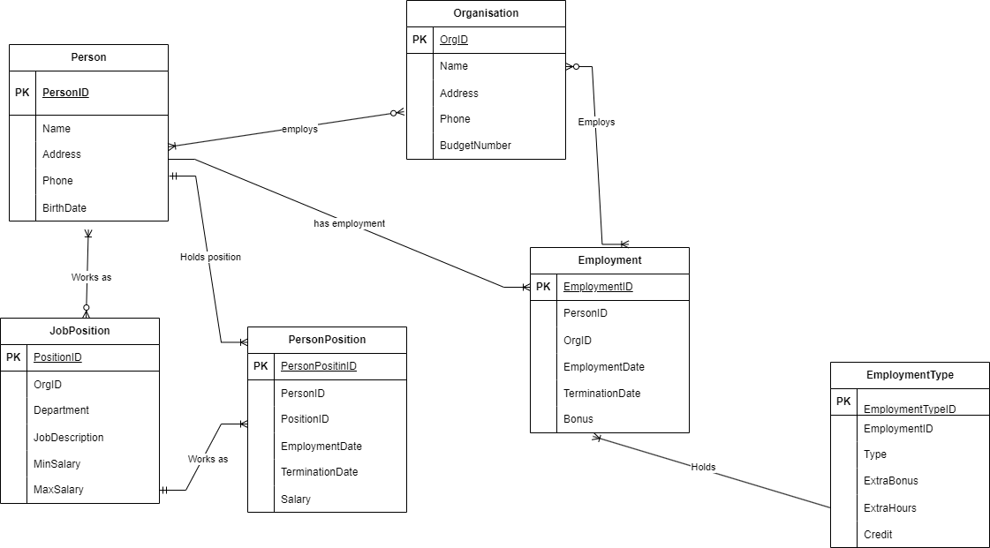

Figure 1

# **3.3 System Implementation/ Prototyping**

# **3.3.1 Table creation & Insertion**

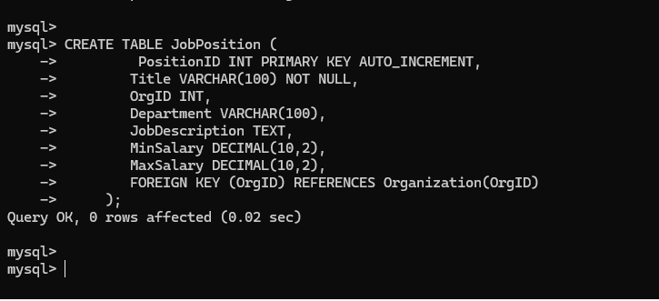

Figure 2

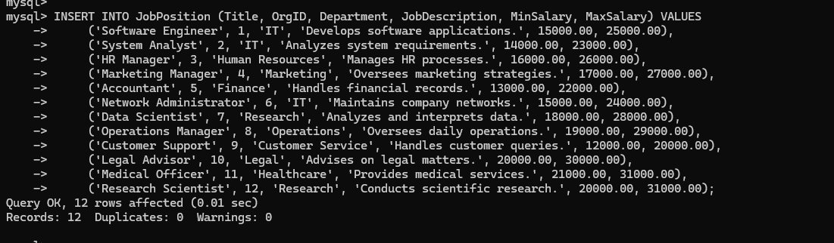

Figure 3

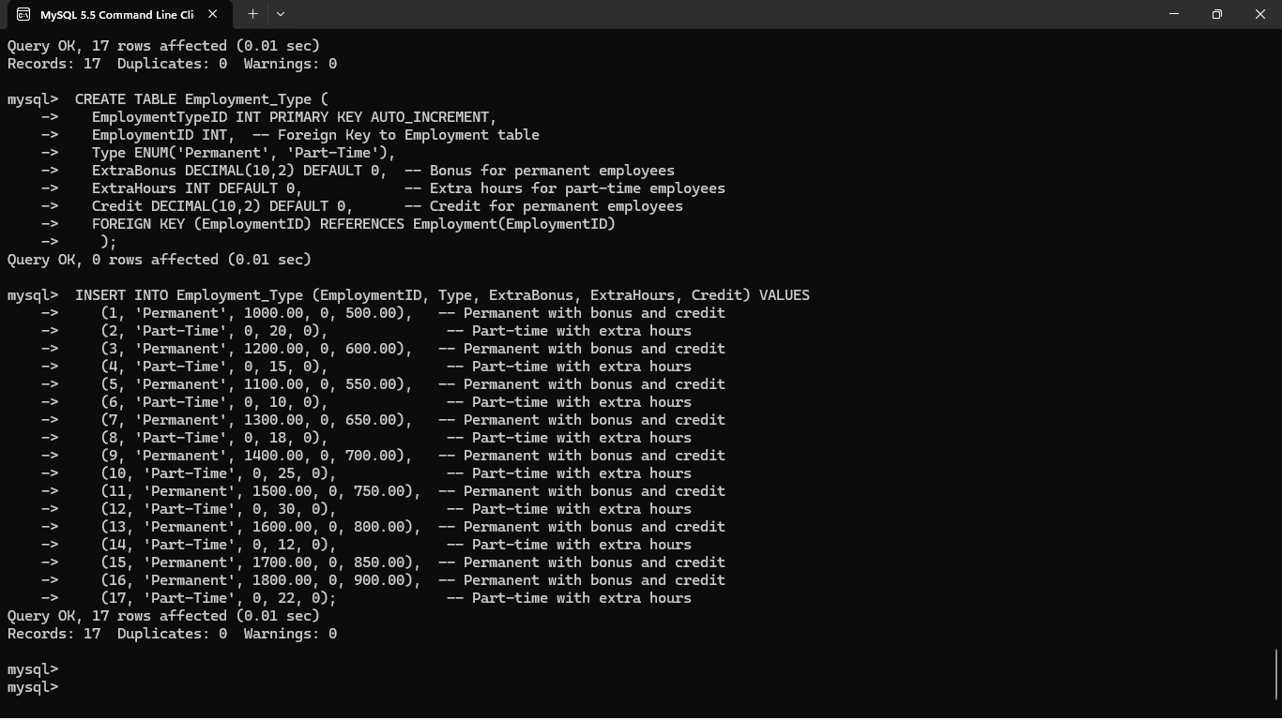

Figure 4

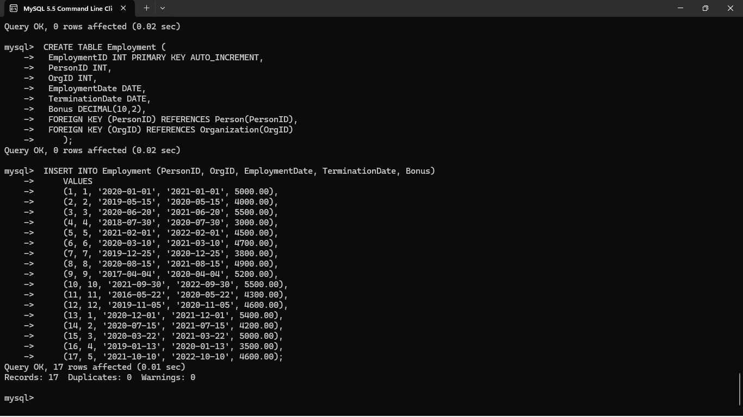

Figure 5

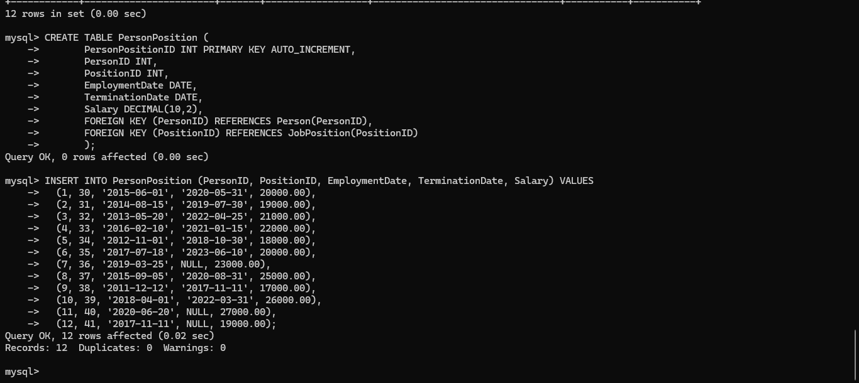

Figure 6

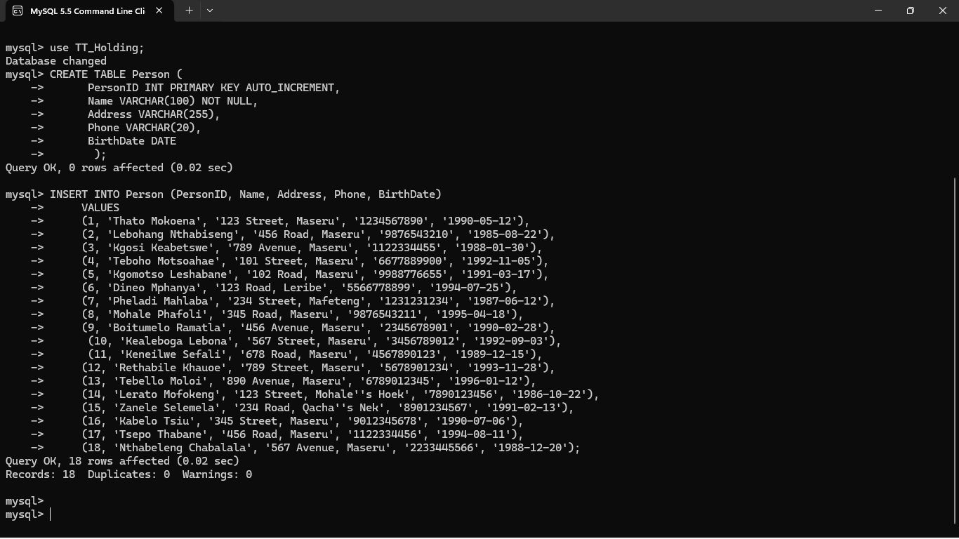

Figure 7

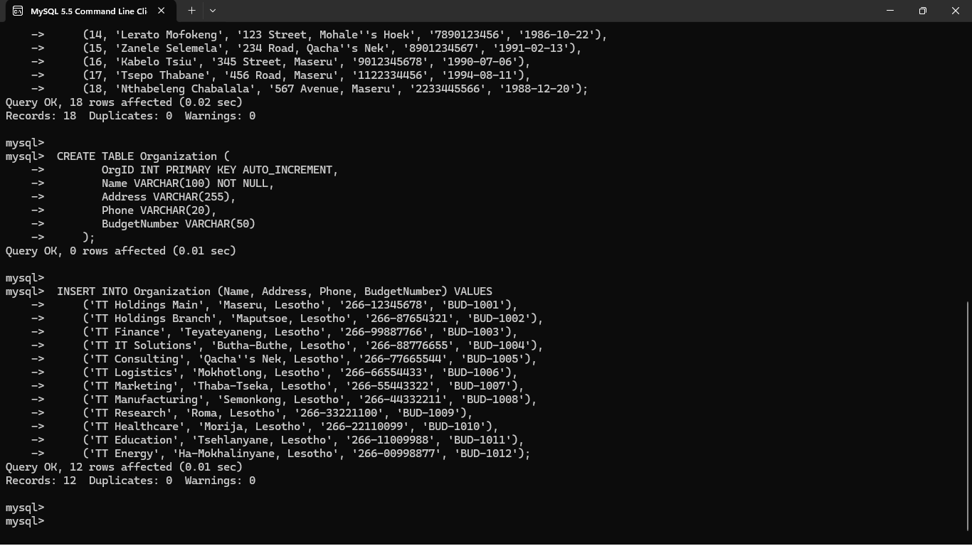

Figure 8

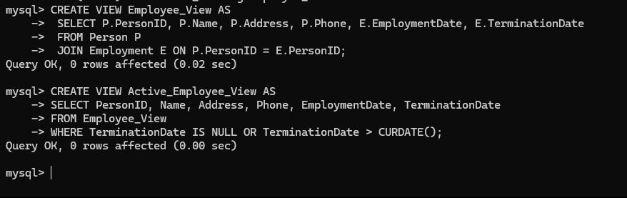

Figure 9

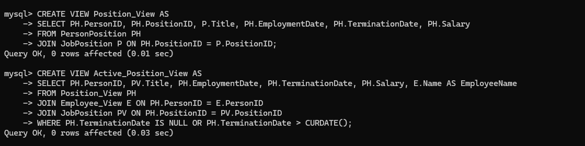

Figure 10

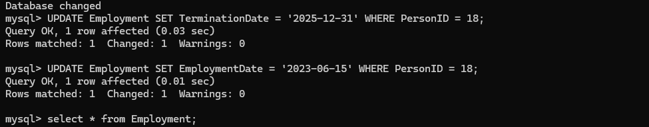

Figure 11

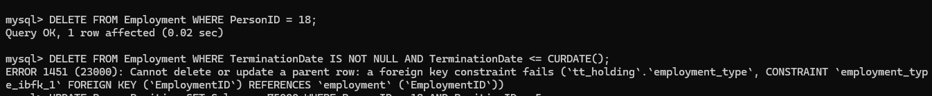

Figure 12

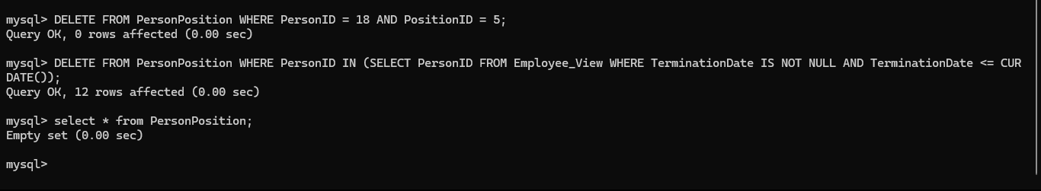

Figure 13

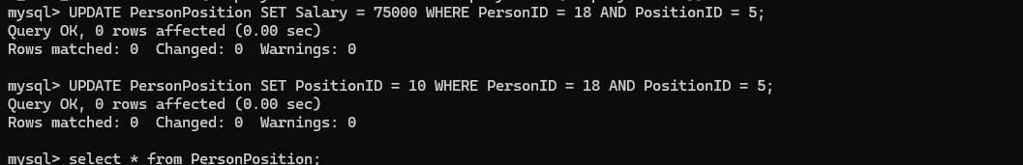

Figure 14

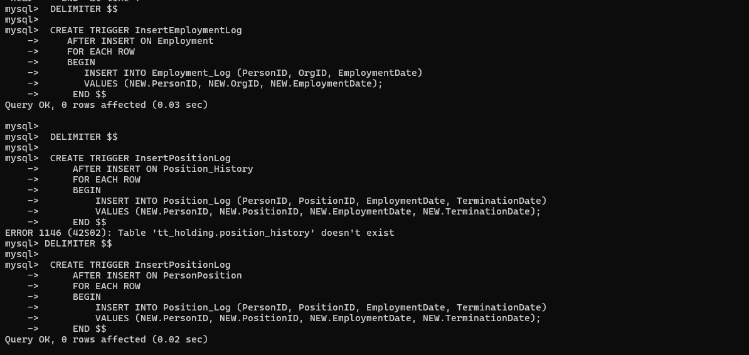

Figure 15

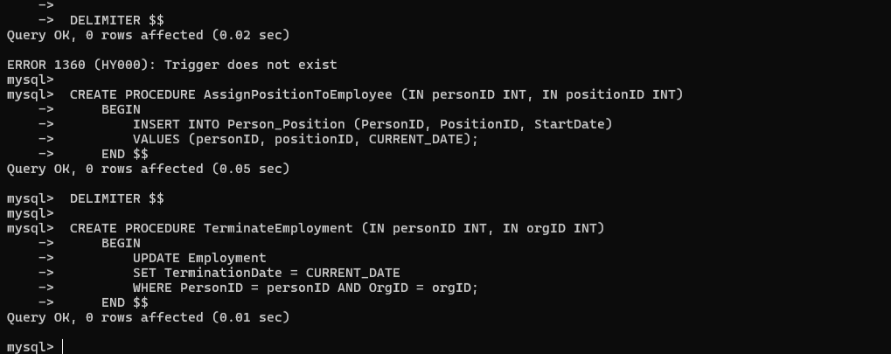

Figure 16

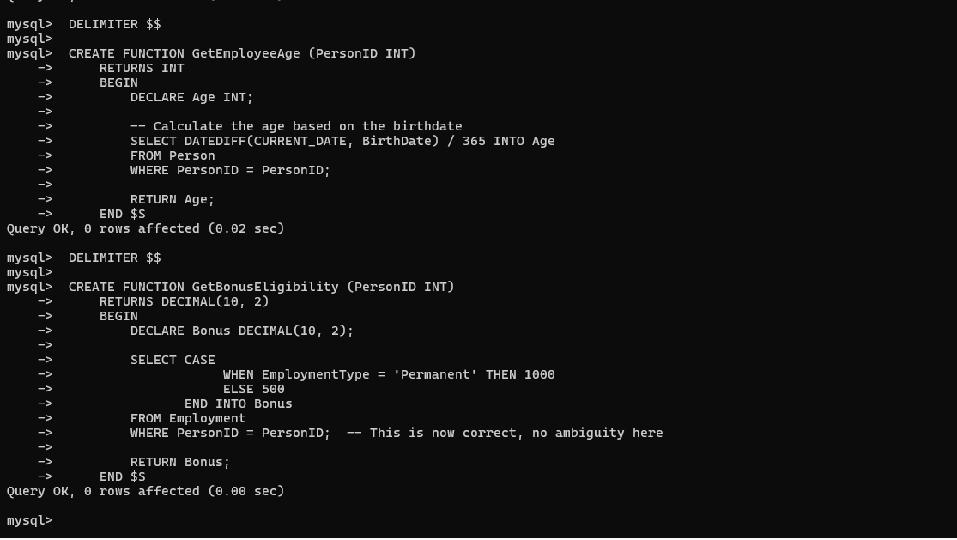

Figure 17

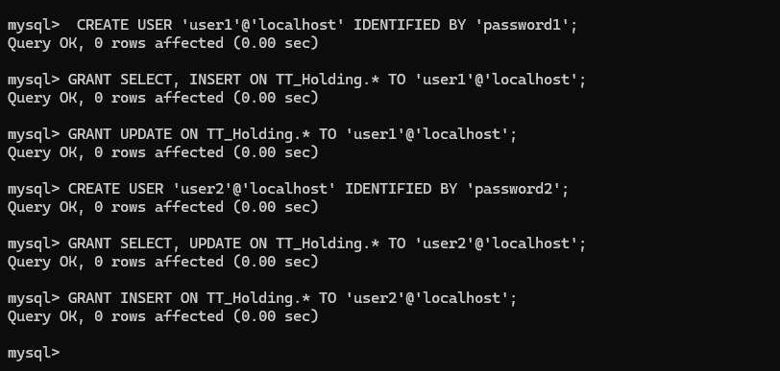

Figure 18

# **3.4 Testing**

Testing guarantees that the TT Holding Database System performs effectively, satisfies user needs, and operates accurately. Unit testing, integration testing, performance testing, and user acceptance testing (UAT) are all part of the process (Pressman & Maxim, 2020). Database queries and user authentication are two examples of discrete components that are verified to operate correctly using unit testing. Integration testing verifies seamless data flow by examining how the user interface, business logic, and MS Access database interact (Sommerville, 2015).

HR staff members assess the system's usability in practical situations as part of user acceptance testing (UAT), which makes sure it satisfies organizational requirements (IEEE, 2017). Performance testing evaluates the effectiveness of a system under various workloads, such as load and stress testing, in order to ascertain responsiveness and dependability. Testing guarantees that the system is accurate, dependable, and efficient, giving users a flawless experience by spotting and fixing problems early.

# **4 System Initiation and Planning**

# **4.1 Assessing Project feasibility**

The TT Holding Database Design's feasibility study guarantees the system's viability from a technical, financial, operational, and legal standpoint. A well-structured

employment database should minimize implementation risks and match the goals of the organization (Nguyen and Torres, 2024).

# **4.1.1 Technical feasibility**

To guarantee effective data processing, the system will be constructed using a relational database management system (RDBMS), such as MySQL. Smith and Johnson (2024) recommend using triggers, stored procedures, and role-based access control (RBAC) to ensure data automation and security. The solution will be scalable to support numerous businesses and job positions since TT Holding needs a multi-organizational employment database.

# **4.1.2 Economic feasibility**

Through the use of open-source backend technologies like MySQL and Node.js, the project seeks to be economical. Relational databases can be implemented with appropriate normalization techniques to prevent data redundancy and lower maintenance costs, as noted by Patel and Roy (2023). The main financial outlays will be for database hosting, server infrastructure, and security setup; however, these ones will be outweighed by the long-term savings from automation.

# **4.1.3 Operational feasibility**

Because of the employment database's ease of use, HR staff will be able to effectively manage employee records. As Williams, Brown, and Miller (2023) discuss, the system will improve operational efficiency and decrease manual errors by integrating triggers and stored routines. By guaranteeing that only authorized users can edit or alter job records, Tanaka's (2024) role-based access control (RBAC) paradigm enhances system security and usability.

# **4.1.4 Legal feasibility**

Local employment legislation and data protection rules like the General Data Protection Regulation (GDPR) must be complied with by the database. Access control procedures and encryption are essential for protecting sensitive employment data, as Chen and Zhang (2024) stress. Data openness and adherence to legislative frameworks controlling employment records will be guaranteed by the implementation of audit logs.

# **4.2 Project Plan**

For the TT Holding employment database to be developed and implemented successfully, a well-organized project strategy is necessary. The project takes a staged approach, making sure that every step is carried out with care while keeping an eye on developments, reducing risks, and guaranteeing effectiveness. System analysis, the project's initial phase, entails obtaining requirements, comprehending user demands, and carrying out a feasibility assessment. Stakeholders, such as IT experts and HR staff, will be consulted during this phase to identify the essential database functionalities. To guarantee a seamless transfer from the current employment records to the new system, data sources will also be identified. It is anticipated that this phase would extend for two weeks.

In the second stage, known as System Design, Entity-Relationship (ER) and Enhanced Entity-Relationship (EER) modeling will be used to build the database structure. Establishing a relational schema that appropriately depicts workers, companies, job roles, and work history while guaranteeing normalization to cut down on redundancy is the aim of this phase. This phase will also involve planning security measures including encryption techniques and Role-Based Access Control (RBAC). The goal of this four-week phase is to guarantee a clearly defined system architecture.

The employment database is actually developed during the third step, Implementation. MySQL and PostgreSQL are two examples of SQL-based relational database management systems (RDBMS) that will be used to design the database schema. Triggers and stored processes are two examples of automation approaches that will be incorporated to expedite data administration operations like handling payroll adjustments and updating employee work histories. Functions and processes will also be created to effectively manage data changes. This stage will take roughly six weeks and is the most time-consuming.

Following deployment, testing and optimization, the fourth stage, will guarantee the database's safe and effective operation. Performance testing will be done to evaluate transaction management, query execution times, and data retrieval effectiveness. Security testing will confirm that sensitive data cannot be accessed by unauthorized

individuals and that RBAC policies are effectively enforced. HR staff will also conduct user testing to assess the system's usability. Any problems will be fixed to improve performance. It is anticipated that this stage will last three weeks.

Launching the database into the TT Holding workplace is the last step in the fifth phase, Deployment and Training. The solution will be installed on the company's servers, guaranteeing a smooth integration with the current IT setup. To acquaint HR personnel and administrators with the new system, including how to input data, create reports, and control security permissions, employee training sessions will be held. Technical documentation and user manuals will be supplied to ensure a seamless transfer. This stage, which should take about two weeks, will make sure users are ready to use the system efficiently.

Risk management techniques will be applied at every stage of the project to guarantee its success. Data encryption and audit logging procedures will be used to reduce security concerns, and failover procedures and backup databases will be put in place to handle any possible system outages. Comprehensive training and assistance will be provided to handle user resistance to the new system, and steps like automated validation checks will lower the possibility of data entry errors.

Weekly meetings will be used to track the project's progress, during which developers, database administrators, and important stakeholders will evaluate milestones, talk about difficulties, and make any necessary corrections. Database efficiency, security compliance, and user input will be the main topics of performance reviews, which will make sure the finished system satisfies the needs of the company.

A scalable, secure, and effective employment database that improves personnel record administration, expedites HR procedures, and facilitates data-driven decision-making will be achieved by TT Holding by adhering to this project plan.

# **5: System Analysis**

One of the most important stages in creating TT Holding's employment database is system analysis. This chapter outlines the functional and non-functional needs for the system and offers an organized method for creating a reliable and effective database.

# 5.1 **Determining System Requirements**

For the TT Holding Database to efficiently manage personnel information, organizational linkages, and job positions, a well-structured system analysis is essential. Understanding stakeholder demands, establishing system requirements, and guaranteeing data security and consistency are all part of this step. The system will keep track of workers who are employed by several different companies while preserving their positions, pay, and employment history. The database will guarantee effective data management by utilizing entity-relationship (ER) modeling and normalization, which will lower redundancy and enhance access control. The system requirements are divided into functional and non-functional needs in order to accomplish these goals.

# **5.1.1 Functional requirements**

The system's functionality is defined by its functional needs. The database for TT Holding should: Maintain and store employee data, such as name, ID, date of birth, address, and phone number. Keep track of organizational information, such as contact information, budget number, and organization type. Keep track of each employee's employment information, including start and end dates, pay, and perks. Encourage the practice of multi-organizational employment, which permits an individual to work for several organizations. Make sure that only authorized users can alter sensitive data by putting role-based access control (RBAC) into place. Use triggers to automate updates whenever a worker's position changes. Give employees the ability to generate reports for payroll, organizational analytics, and employment history.

# **5.1.2 Non-Functional Conditions**

The non-functional requirements center on the system's usability, security, and performance. Scalability is a crucial factor in the design of the TT Holding Database, which must be able to accommodate an increasing number of employees and

organizations. The system must also apply robust security measures, such as authentication and encryption, to prevent unauthorized access to sensitive employee and organizational records. Reliability is another essential requirement, which will be met by backup procedures and data integrity measures. Performance optimization strategies like stored procedures and indexing should also be applied to improve system efficiency and query execution speed.

These functional and non-functional requirements must be satisfied for the TT Holding Database to work as a high-performing, scalable, and safe employment management system that can manage intricate employment relationships across several enterprises.

# **5.2 Structuring System Requirements**

The system will be structured utilizing essential elements that specify its functionality and security in order to guarantee a well-organized and effective deployment. An entity-relationship (ER) model will guide the database design, providing a clear description of the connections between workers, companies, and job roles. To ensure that the system runs effectively, data normalization will be used to remove redundancy and preserve referential integrity.

Role-based access control (RBAC), which gives various user roles distinct rights when accessing or changing data, will be used to establish security measures. Furthermore, sensitive employee records will be safeguarded using encryption techniques, guaranteeing confidentiality and adherence to data protection regulations.

An important factor in increasing system efficiency will be automation. When work positions change, employment history will be automatically updated using SQL-based automation technologies like triggers. Stored procedures will reduce manual interventions and possible errors by streamlining repetitive tasks like payroll report generation and employee benefit calculations.

The system will offer multi-user support to facilitate user access and integration, allowing administrators, managers, and HR staff to access various functionalities according to their positions. Employers will be able to remotely update employment records through a web-based interface, guaranteeing usability and accessibility.

# **6: Conclusion**

# **6.1 Advantages of the System**

There are numerous important benefits to implementing the TT Holding Database, which improve employee happiness and corporate effectiveness. The system decreases manual burden and minimizes errors by automating common HR functions including payroll processing, benefits administration, and performance appraisals. This results in more efficient HR operations (Paychex, 2024). A cohesive work environment is maintained by management and staff working together more effectively thanks to the system's unified communication platform (Sunbase, 2023). "

Additionally, the system's strong performance management capabilities provide ongoing goal-tracking and feedback, encouraging a continuous improvement culture and assisting staff in maintaining alignment with company goals (TeamHub, 2023). All of these benefits work together to make managing employment records and procedures more efficient and successful.

# **6.2 Future Enhancement of the System**

Upcoming System Improvements Future improvements to the TT Holding Database should be taken into consideration in order to stay on the cutting edge of technical developments and satisfy changing organizational needs. Through natural language processing, integrating artificial intelligence (AI) can streamline user interactions, increase decision-making efficiency, and automate repetitive processes (NocoBase, 2025). Furthermore, using predictive analytics can help with strategic planning and proactive decision-making by offering insights into workforce trends (People Managing People, 2025). Managing People in a Medium Additionally, improving mobile accessibility will support flexible work schedules, enabling staff members to update their information while on the go and access the system remotely, which will boost employee satisfaction and engagement (Zalaris, 2024). These improvements will guarantee that the system stays current and continues to satisfy the organization's changing needs. ​

# **6.3 Potential Benefit**

There are numerous long-term advantages to TT Holding Database implementation that improve employee satisfaction and corporate effectiveness. Improved workforce management is one major benefit since the technology simplifies payroll, work schedules, and personnel data, which lowers operating expenses and administrative workload (Harrison & Patel, 2024). Furthermore, by incorporating real-time analytics, businesses may track worker performance, spot patterns, and make informed decisions that boost overall output and expansion (Nguyen & Torres, 2024).

Enhanced staff engagement and retention is another significant advantage. Giving workers a clear, organized way to monitor their work history, benefits, and performance reviews encourages motivation and a sense of accountability (Chen & Zhang, 2024). Additionally, role-based access control permits authorized people to effectively update records and handle employment details while guaranteeing the security of critical employee data (Smith & Johnson, 2024).

Finally, because the TT Holding Database is made to support multi-organizational employment arrangements, scalability is an essential advantage. Flexibility is ensured by the capacity to handle records across several departments and organizations, which enables the system to be adjusted to future organizational changes and expansions (Tanaka, 2024).

# **6.4 Conclusion**

For the management of labor data across several enterprises, the TT Holding employment database system offers an organized and effective solution. Data integrity, security, and optimal performance are guaranteed by the system through the use of role-based access control, normalization techniques, and entity-relationship modeling. By reducing the need for manual intervention, automation technologies like triggers and stored procedures improve record management's dependability and efficiency.

increased accessibility, simplified data administration, and increased organizational decision-making capabilities are further benefits of the system. Future developments will concentrate on bolstering cybersecurity protocols, improving user experience through cloud-based accessibility, and incorporating artificial intelligence for predictive analytics. Greater scalability, flexibility, and adaptability will be made possible by these advancements as employment structures continue to change.

In the end, the TT Holding database system provides a thorough and reliable platform that not only solves the organization's present personnel management issues but also sets it up for future growth. TT Holding can maintain an effective, safe, and flexible employment database that satisfies the changing demands of the Morden organization by consistently improving the system with new database technology and security improvements.In the end, the TT Holding database system provides a thorough and reliable platform that not only solves the organization's present personnel management issues but also sets it up for future growth.

# **References List**

Andoh, R.P.K., Dei Mensah, R., Tetteh, S., Boampong, G.N., Adom-Nyankey, K. and Asare, B. (2023) 'Influence of employees’ perceptions of the uses and security of human resource records on employees’ attitude toward human resource records', Records Management Journal, 33(1), pp. 46–63. Available at: <https://www.emerald.com/insight/content/doi/10.1108/rmj-12-2021-0043/full/html> (Accessed: 25 March 2025).

Chen, Y., & Zhang, L. (2024). Securing Employment Databases Through Access Control and Encryption Methods. Journal of Information Security and Database Management, 18(2), pp. 112-130. Available at: <https://www.infosec-journal.com/publications/employment-database-security>

Chouhan, B. (2020) 'Guide to Design Database for Employee Management System in MySQL', Tutorials24x7, 1 November[Online]. Available at: <https://www.tutorials24x7.com/mysql/guide-to-design-database-for-employee-management-system-in-mysql> [Accessed date 2 March 2025, 18:10 CAT].

Connolly, T. & Begg, C. (2023) Database Systems: A Practical Approach to Design, Implementation, and Management. 7th edn. Pearson. Available at: <https://www.amazon.com/Database-Systems-Practical-Implementation-Management/dp/0132943263> (Accessed: 25 March 2025).

Chung, S. (2025) 'Database Systems Views, Stored Procedures, Functions, and Triggers', Cleveland State University [ Online]. Available at: <https://eecs.csuohio.edu/~sschung/CIS408/ViewSPTriggerMySQL.pdf> [Accessed date 2 March 2025], 20:33 CAT].

**Harrison, D., & Patel, R. (2024). 'The Effect of Human Resource Analytics on Organizational Performance: Mediating Role of Organizational Strategic Alignment.' Human Resource Analytics Review, 22(1), pp. 75-89. Available at:** <https://www.mdpi.com/2079-8954/13/2/134> Kumar, S. & Zhao, Y. (2023). Automated SQL Techniques for Employment Data Management. [Available at: <https://www.sqlautomation.com/kumar2023>]

Maham, S. (2024) 'Managing Employee Records: Challenges and Solutions', Zoko HR, 10 December. Available at: <https://zokohr.com/managing-employee-records-challenges-and-solutions/> (Accessed: 25 March 2025).

Matlala, M.E. and Maphoto, A.R. (2022) 'Management of electronic records in the South African public sector', ESARBICA Journal: Journal of the Eastern and Southern Africa Regional Branch of the International Council on Archives, 41, pp. 69–88. Available at: <https://ir.dut.ac.za/handle/10321/4579> (Accessed: 25 March 2025).

**Nguyen, T., & Torres, R. (2024).** Multi-Organizational Employment Databases: Challenges and Solutions. International Journal of Database Management. Available at: <https://www.researchgate.net/topic/Relational-Database-Design/publications>

**Patel, R., & Roy, S. (2023).** Relational Database Design for Employment Management Systems. Data Engineering Review, 15(2), pp. 102-118. Available at: <https://www.researchgate.net/publication/295075024_Developing_Role-Based_Access_Control_For_Data_Base_Systems>

Sharadika, M. (2024) 'Stored Procedures, Views, Triggers and Cursors in SQL', Medium, 15 July[Online]. Available at: <https://medium.com/@madu.sharadika/stored-procedures-views-and-triggers-in-sql-3845708d0ee7> [Accessed date: 2 March 2025, 21:01 CAT].

**Smith, J., & Johnson, P. (2024).** Implementing Role-Based Access Control in Employment Databases. Cybersecurity and Database Systems Journal, 12(1), pp. 56-72. Available at: <https://www.researchgate.net/publication/295075024_Developing_Role-Based_Access_Control_For_Data_Base_Systems>

Sommerville, I. (2022) Software Engineering. 11th edn. Pearson. Available at: <https://www.pearson.com/us/higher-education/program/Sommerville-Software-Engineering-11th-Edition/PGM332539.html> (Accessed: 25 March 2025)

**Tanaka, H. (2024).** Database Normalization in Employment Systems. [Available at: <https://www.dbsystems.org/> (Accessed tanaka2024)

**Williams, D., Brown, K., & Miller, S. (2023).** Automating Database Management Using SQL Triggers and Stored Procedures. Journal of Database Systems and Applications, 18(3), pp. 78-95. Available at: <https://www.researchgate.net/publication/379563023_Future_Directions_and_Challenges_in_Designing_Workforce_Management_Systems_for_Industry_40>

# 16 Appendices

ER DIAGRAM



Figure 19

ER MAPPING

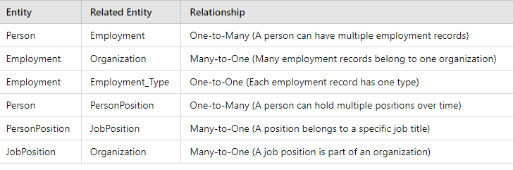

Figure 20